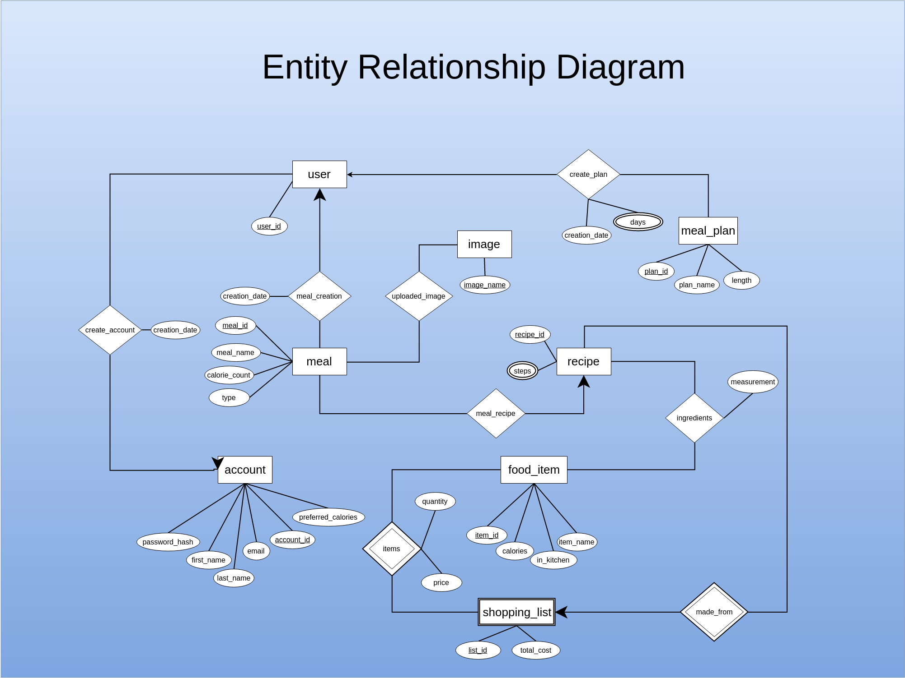

Diagram 1: Entity Relationship Diagram

Assumptions:

• The user can exist and interact with the application without creating an account

The schemas are shown below.

Strong entities:

# user(user_id)

* account(account_id, preferred_calories, first_name, last_name, email, password_hash)
* image(image_name)
* food_item(item_id, calories, item_name, in_kitchen)
* recipe(recipe_id, steps)
* meal_plan(plan_id, plan_name, no_of_weeks)

<days attr. should be attached to meal_plan entity>

<name change: length 🡪 no_of_weeks>

* meal(meal_id, meal_name, calorie_count, type)

Weak entities:

* shopping_list(list_id, total_cost)

Derived entities:

* meal_creation(meal_id, user_id, creation_date)
* create_account(user_id, account_id) <should be 1:1 rel.>
* create_plan(plan_id, user_id, creation_date)
* days(week_number, day_name, breakfast, lunch, dinner, snack)
* steps(recipe_id, step_number, step)
* *recipies_created(account_id, recipe_id) <don’t remember where this came from, but I think it should be there>
* items(list_id, item_id, quantity, price)
* ingredients(recipe_id, item_id, measurement)

# upload_image(image_name, meal_id)

# meal_recipe(recipe_id, meal_id) <should be 1:1 rel.>

# made_from(recipe_id, list_id) <possibly redundant relationship, could be achieved by joining items with shopping_list>